04/09/2025

**Power Bi Assignment**

**Comparison between Stacked column and clustered column using Target Line:**

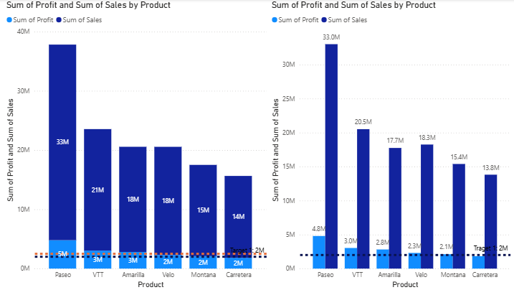 Constant line is a fixed horizontal reference line used to highlight a specific value across the chart. In **Stacked Column Chart**, the Target line helps compare the **total value of stacked categories** against the target. In **Clustered Column Chart**, the Target line helps compare **each individual category’s value** directly against the target.

To create a **stacked Column chart:**

1. go to **Visualizations** and select the stacked column chart, clustered column chart.
2. On the **X-axis**, place the **Product** field.
3. On the **Y-axis**, place the **Sales and Profit** field.
   * It will automatically change to **Sum of Sales and Sum of Profit**.
4. Legend on.
5. Data label on.

**Analytics:**

Go to analytics **→** Y-axis Constant line **→** Add new line for Target Line name at Target 1

Line **→ value (put value) → color → Trenchancy → Line style → Width → Position**

To create a **Clustered Column chart:**

1. go to **Visualizations** and select the stacked column chart, clustered column chart.
2. On the **X-axis**, place the **Product** field.
3. On the **Y-axis**, place the **Sales and Profit** field.
   * It will automatically change to **Sum of Sales and Sum of Profit**.
4. Legend on.
5. Data label on.

**Analytics:**

Go to analytics **→ Y-axis Constant line** **→** Add new line for Target Line name at Target 1

Line → Add new line → value (put value) → color → Trenchancy → Line style → Width → Position

**Min line** → Add new line → value (put value) → color → Trenchancy → Line style → Width → Position

**Max line** → Add new line → value (put value) → color → Trenchancy → Line style → Width → Position

**Average line** → Add new line → value (put value) → color → Trenchancy → Line style → Width → Position

**Median line** → Add new line → value (put value) → color → Trenchancy → Line style → Width → Position

**Percentile line** → Add new line → value (put value) → color → Trenchancy → Line style → Width → Position

**Error Bars**

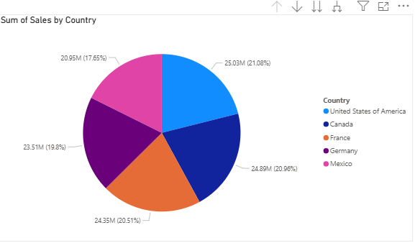 **Drill Down and Drill Through:**

* Drill Down in Power BI lets you explore data within the same visual, moving from summary (higher level, e.g., Year) to detail (lower level, e.g., Month, Day).
* Drill Through allows you to navigate to a separate, detailed report page filtered for the selected data point, giving deeper context and insights.

**For each categorical data create pie chart for sales**

To create a **Pie chart:**

1. go to **Visualizations** and select the Pie chart.
2. On the **Legend**, place the **Country, Discount Band, Product, Segment** field.
3. On the **Values** place the **Sales** field.
   * It will automatically change to **Sum of Sales.**
4. Legend on.
5. Details label on.

**Drill Down** → select back arrow  → select one country → select one Discount Band → Select one Product → Select one Segment, it will shows the particular County details only.

**Drill Through**  it will shows all country details in single page.

**Date Stacked column chart and Slicer:**

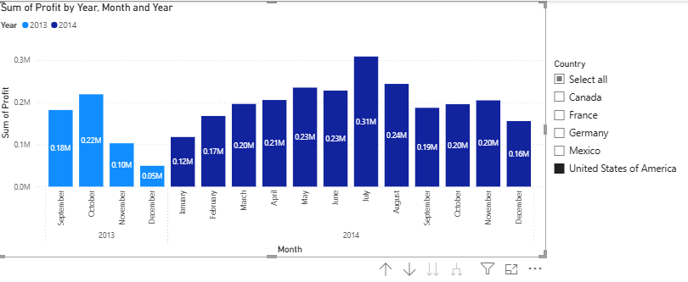

In a Stacked Column Chart with a date field, the X-axis usually shows time periods (Year, Quarter, Month, Day) in this what do you need you choose it.  
The Y-axis shows the total value, with each column divided (stacked) by categories like region or product. This helps track trends over time while comparing the contribution of each category to the total.

To create a **Stacked Column chart:**

1. go to **Visualizations** and select the Stacked Column chart.
2. On the **X-axis** place the **Date** field.
3. On the **Y-axis** place the **Profit** field.
   * It will automatically change to **Sum of Profit.**
4. For color Propes we use **Legend** place the **Year** filed.
5. Legend on.
6. Data label on.

**Slicer:**

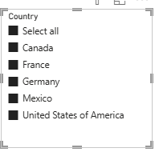

To create a **Stacked Column chart:**

1. go to **Visualizations** and select the Slicer.
2. On the Field place the **Country.**

**Format Visual** → Slicer Setting → Option → Style Vertical list or Tile or Dropdown → Selection Single Selection or Multi-select or Show select all

**Slicer Header** on.